- Reflection of light

- Place a sheet of paper on the table in front of  the mirror then use the ruler to trace the pathway  of the beam to and from the mirror.  - Label the incidence beam and the reflective beam.  - Using a protractor, measure these angles in  degrees. Record your results in the table below. | 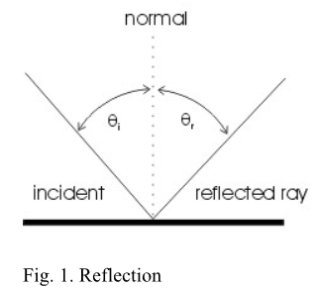

Trial | Angle of incidence θi | Angle of Reflection , θr
1
2
3
4
Draw the normal and reflected rays knowing the
Law of Reflection (θi=θr) . Write the values of the angle of incidence and angle of reflection in the table above.

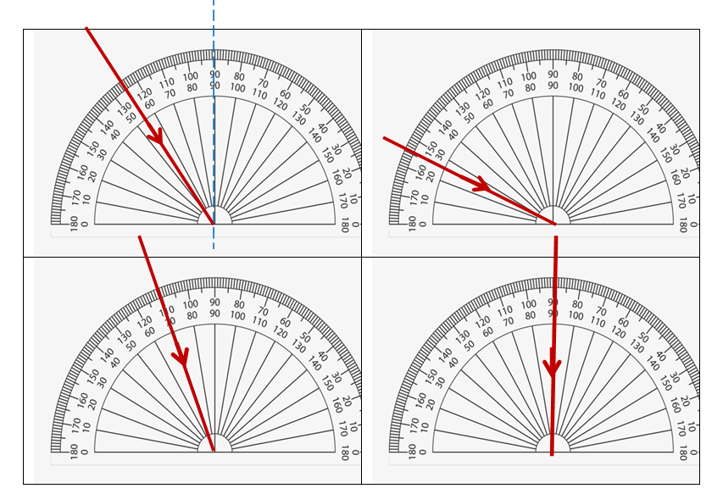
How do the angle of incidence and the angle of reflection compare for each trial?

B: Refraction of light
Data Processing and Presentation:
Measure the angle of refraction, θ_{r} for four different angles of incidence θ_{I} (angles given in the pictures below). In the table below record these angles and calculate and record the sin of angles (θi) and the sin of angles (θr).
Trial | θ_{i (deg)} | θ_{r (deg)} | sin (θ_{i} ) | sin(θ_{r}) | n = sin θ_{i} / sin θ_{r}
1. | 50.61 | 35.43
2. | 72.76 | 45.76
3. | 16.68 | 12.43
4. | 87.68 | 48.55

- Calculate the average refractive index of all your data points.

- Show a sample calculation (numerical values) for your working and explain it.
n = sin θ_{i} / sin θ_{r} ….
- Based upon the lab and the class discussion, explain what the index of refraction of a medium tells you about that material?
- If you have two liquids; one with an index of refraction 1.67 and the other with an index of refraction of 1.22 which liquid would cause light to refract the least?
- Describe where you would appear to a fish looking at you from under water. Draw a sketch.
air  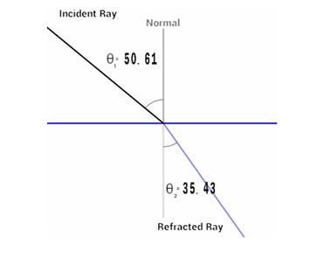  unknown transparent  material | 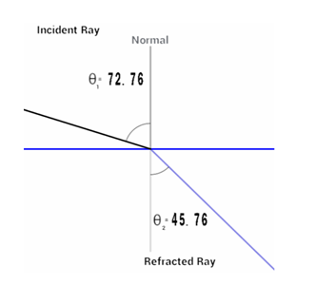
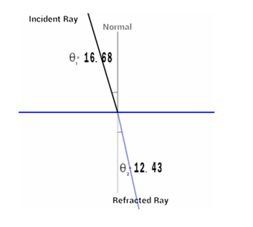 | 